Game Console Development COMP10037

Detecting Regions of inTerest using a cell processor

B00236297 – LIVINGSTONE, JONATHAN B00235610 – TAYLOR, WILLIAM B00243868 – TOADER, CONSTANTIN

# Overview

There is a requirement to develop an automatic *Region of Interest (ROI)* detector as part of a cancer cell analysis computer vision application. A ROI is a region detected within an image scene that bounds a target object of interest with an image. The same concept appears commonly in face-detection and gesture recognition software.

The solution proposed for this problem is to develop an application that should be optimised to run on PS3 Cell Broadband Engine hardware to exploit as much of the available processing power as possible.

The ROI detector that is to be developed, should be capable of detecting ROIs from a video sequence of rat prostate cancer cells. The premise is that a bounding box selects a likely cell from the background image from frame to frame.

The solution is inspired by Phung and Bouzerdoum (2007)[1] where a box with a certain edge density will be the likely target ROI. The edge density map for the image is searched until an appropriate candidate is found. This requires that the edge densities are averaged for many rectangular boxes in the search space.

Initially edge densities are to be found using simple kernel processing. The Sobel transform suggested by Juneja, Sandhu (2009)[2] will help generate a gradient map to find edges from each original image that forms the video sequence.

In the following phase the solution will be ported on the PS3 Cell Broadband Engine and all the compatibility issues will be solved, so our solution will natively run on a PS3.

Finally, the application will be adapted to use optimised SIMD intrinsics, multicore decomposition, SPU intercommunication and algorithmic optimisation where possible.

Output and timing will be taken and analysed at each step and our findings will be presented in the conclusion part of this paper.

# Background work

When it comes to differentiating objects from non-objects, or identifying *Regions of Interest*, there are a plethora of resources available. This is probably why the progress in Computer Vision is so remarkable, allowing us to frequently use related technologies in: s*ecurity* (CCTV), *road and driving safety (*traffic signs or lane recognition embedded in the latest generation of cars), *image search* (Google Image), *health* (medical diagnosis based on patterns recognition), *retail* (UPC barcode), *games industry* (Microsoft Xbox Kinect), *augmented reality*, et cetera.

It is not very clear who started the first research on edge detection, but Szeliski (2010)[3] places the beginning of edge detection in the 1970s with research into better edge and contour detection continuing through the 1980s.

Canny (1986)[4] took an analytical and mathematical approach on edge detection, using numerical optimisation to find operators to be used with edge detection, trying to find a balance between detection quality and localisation. He created designs for detectors using operators of different values to cope with different signal to noise ratios in an image and came up with a general method which can be used for different images. This paper will use a variation of Canny’s edge detection algorithm and will be presented in the next chapter.

Nalwa and Binfdord (1986)[5] define an edge in an image as being an intensity discontinuity in the scene. Edges are made of small linear segments named *edgels,* each represented by a position and an angle*;* basically, any curve can be represented as a sequence of edgels which further form an edge. They designed an approach where they detect edgels in one-dimensional surfaces. They highlight that their algorithm performs effective noise-reduction without blurring the edges too much and is implementable as a parallel process. The algorithm used in this paper will try to make use of parallelism and will be implemented to run on the CELL processor.

Xue, Wenxia and Guodong (2015)[6] used cellular neural networks to prove their algorithm efficiency in edge detection. They compare their output with different operators like Sobel, Roberts, Prewitt, LOG, Canny, 1 CNN and 2 CNN. From their test results, it is visible that their method outputs more edges and seems to be more clear than others, but along with thicker and better contoured edges, some noise is also visible in the output. Comparing 1 CNN template against 2 CNN template, and considering that both output noise, the later does indeed return a sharper, more accurate output when it comes to edge detection. Unfortunately, as previously stated, with these 2 methods (CNN Neighbourhood radius equals 2 and CNN Neighbourhood radius equals 1) noise is also present in the result, reducing the quality of the algorithm.

To better identify ROIs, XIA, FENG et. al. (2009)[7] do not rely only on edge detection. When computing the salient map introduced by Itti (1998)[8], they consider another feature as well: the depth. They noticed differences between Itti’s method and the human vision perception. Their paper highlights that after the salient map is formed, several ROIs would be grouped and identified as just one object instead of several individual ROIs. Using edge and depth information, the resulted ROIs are more like what humans would consider a ROI. This would be a good fix for the application proposed by this paper, as the same problem occurs here, but it is outside of the scope of this paper.

The proposed solution will try to accommodate some of the previous work done. The application will use Canny’s method, will be implemented for parallel processes and will use hardware that will benefit from the use of intrinsic SIMD, such as the Cell Broadband Engine.

# Methodology

Given a set of ten images, the ROIs will be identified for each individual image using the following methodology consisting of four tasks:

1. Reduce noise using Gaussian Blur.
2. Apply Sobel operator to identify the edges.
3. Create a mask for ROIs.
4. Apply mask on original image

For each image the output is saved for analysis.

To highlight the performance gain when using the CELL processor, the application will be initially developed for PC and the runtime will be measured. Then the application will be ported on the PS3 platform and again the timings will be recorded. Further improvements will be applied by using intrinsic Symmetric Instructions and Multiple Data available on the Cell Broadband Engine. Performance time will be again recorded and findings will be presented in the analysis chapter.

# Algorithms and code

No matter what runtime environment will be targeted, the core algorithm should follow the above-mentioned methodology.

## The PC version

The PC version is basically the root of the application. Considering that is difficult to program without a proper IDE on the Play Station, it felt natural that a working version should be developed for pc first. The images that need to be processed in this application are displayed in Figure 1. They represent 10 frames of a short clip showing cells in motion.

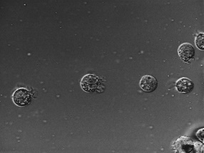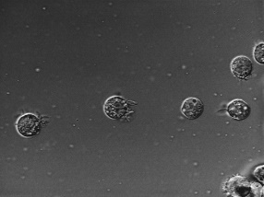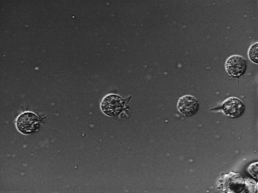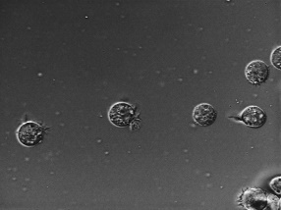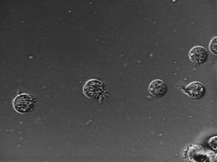

Figure 1. 10 frames of moving cells

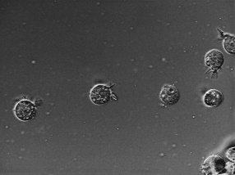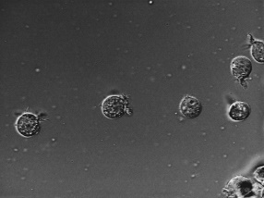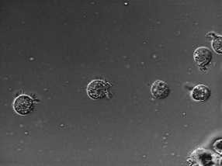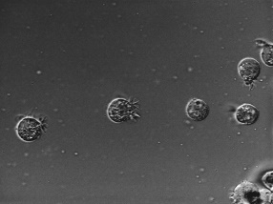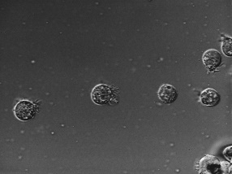

## 1. Noise reduction

First step was to take the original image and reduce noise as much as possible to avoid false positives when detecting edges. This is done by applying Gaussian blur on the image[9]. Each pixel is replaced by the averaged of itself and the surrounding pixels to which the blur filter has been applied.

Let the pixel representation in Figure 2 be the pixel layout of a 10x10 picture. When processing pixel 25 for example, a 3x3 kernel will be generated containing its neighbour pixels.

|  |  |  |  |  |  |  |  |  |  |  |  |  |  |  |
| --- | --- | --- | --- | --- | --- | --- | --- | --- | --- | --- | --- | --- | --- | --- |
| 0 | 1 | 2 | 3 | 4 | 5 | 6 | 7 | 8 | 9 |  |  |  |  |  |
| 10 | 11 | 12 | 13 | 14 | 15 | 16 | 17 | 18 | 19 |  |  |  |  |  |
| 20 | 21 | 22 | 23 | 24 | 25 | 26 | 27 | 28 | 29 |  |  |  |  |  |
| 30 | 31 | 32 | 33 | 34 | 35 | 36 | 37 | 38 | 39 |  |  | 0.111 | 0.111 | 0.111 |
| 40 | 41 | 42 | 43 | 44 | 45 | 46 | 47 | 48 | 49 |  |  | 0.111 | 0.111 | 0.111 |
| 50 | 51 | 52 | 53 | 54 | 55 | 56 | 57 | 58 | 59 |  |  | 0.111 | 0.111 | 0.111 |
| 60 | 61 | 62 | 63 | 64 | 65 | 66 | 67 | 68 | 69 |  |  |  |  |  |
| 70 | 71 | 72 | 73 | 74 | 75 | 76 | 77 | 78 | 79 |  |  |  |  |  |
| 80 | 81 | 82 | 83 | 84 | 85 | 86 | 87 | 88 | 89 |  |  |  |  |  |
| 90 | 91 | 92 | 93 | 94 | 95 | 96 | 97 | 98 | 99 |  |  |  |  |  |

Figure 2. Pixels positions on a 10x10 image with kernel surrounding pixel 25, and a Gaussian blur filter box

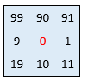The kernel will contain pixels 14,15,16, 24, 25, 26, 34, 35, 36. To apply Gaussian blur, the kernel matrix will have each element multiplied by its correspondent from the filter matrix and the weighted sum of all values will represent the final value of the blurred pixel 25.

A special case is when the pixels that needs processed are at the edge. In this case the pixel could be pushed into the surrounding, where the neighbours are missing, or the pixel can be wrapped around the other side. This will make tiled images seamless. For example, when processing pixel 0, the kernel values should be as in this kernel.

Algorithm:

for each row in input image:

for each pixel in row:

set sum to zero

for each element in kernel row:

multiply filter value corresponding to pixel value

add result to accumulator

set pixel value to sum

After applying blur to the input images, the result is visible in Figure 3.

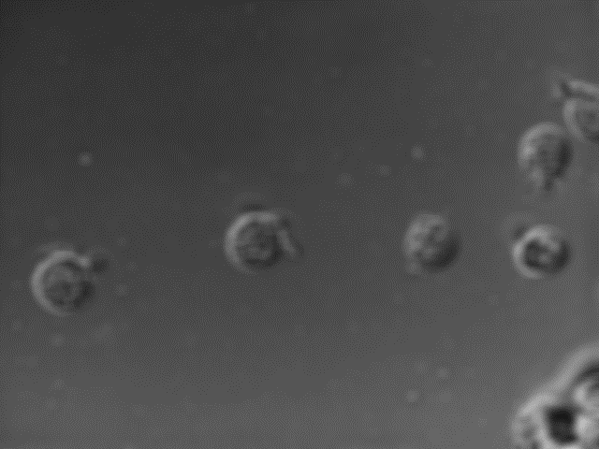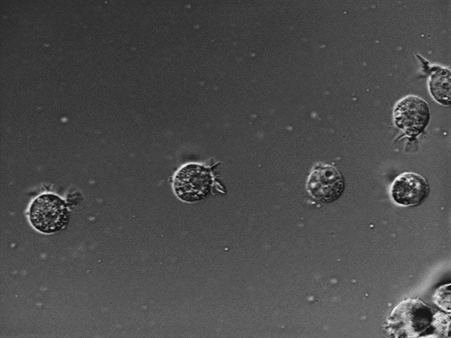

Figure 3. On the left side is the original image, on the right side is the image with noise reduced

## 2. Edge detection

The next step in highlighting the ROIs in the set of input image is to detect the ROIs edges. This will be done using the Sobel[10] operator. Basically, for each pixel in the image the magnitude of horizontal and vertical gradients is computed and the value is assigned to the pixel. If the intensity in change is bigger than a certain threshold, then that pixel is part of an edge, otherwise, the pixel should be ignored (made black).

Similar to the Gaussian blur, the Sobel operator is applied on a 3x3 kernel. The two gradients are obtained: one for x direction and one for y direction and then their magnitude is calculated and assigned to each pixel and if necessary the pixel value is then changed to black. Figure 4.

|  |  |  |  |  |  |  |  |  |  |  |  |  |  |  |
| --- | --- | --- | --- | --- | --- | --- | --- | --- | --- | --- | --- | --- | --- | --- |
| 0 | 1 | 2 | 3 | 4 | 5 | 6 | 7 | 8 | 9 |  |  | horizontal | | |
| 10 | 11 | 12 | 13 | 14 | 15 | 16 | 17 | 18 | 19 |  |  | -1 | 0 | 1 |
| 20 | 21 | 22 | 23 | 24 | 25 | 26 | 27 | 28 | 29 |  |  | -2 | 0 | 2 |
| 30 | 31 | 32 | 33 | 34 | 35 | 36 | 37 | 38 | 39 |  |  | -1 | 0 | 1 |
| 40 | 41 | 42 | 43 | 44 | 45 | 46 | 47 | 48 | 49 |  |  |  |  |  |
| 50 | 51 | 52 | 53 | 54 | 55 | 56 | 57 | 58 | 59 |  |  | vertical | | |
| 60 | 61 | 62 | 63 | 64 | 65 | 66 | 67 | 68 | 69 |  |  | -1 | -2 | -1 |
| 70 | 71 | 72 | 73 | 74 | 75 | 76 | 77 | 78 | 79 |  |  | 0 | 0 | 0 |
| 80 | 81 | 82 | 83 | 84 | 85 | 86 | 87 | 88 | 89 |  |  | 1 | 2 | 1 |
| 90 | 91 | 92 | 93 | 94 | 95 | 96 | 97 | 98 | 99 |  |  |  |  |  |

Figure 4. Pixels positions on a 10x10 image with kernel surrounding pixel 25, and Sobel matrices

The difference is that the input image is now the processed blurry image, which had noise reduced in the previous step.

Algorithm:

for each pixel in input image:

calculate gradient magnitude

for each pixel neighbour

multiply neighbour value with horizontal gradient correspondent

add result to pixel’s horizontal gradient component

multiply neighbour value with vertical gradient correspondent

add result to pixel’s vertical gradient component

return magnitude of the gradient

if gradient is smaller than threshold

ignore pixel (make it black, invisible)

else

highlight the pixel (multiply value)

endif

After applying Sobel to the blurred images, the result is visible in Figure 5.

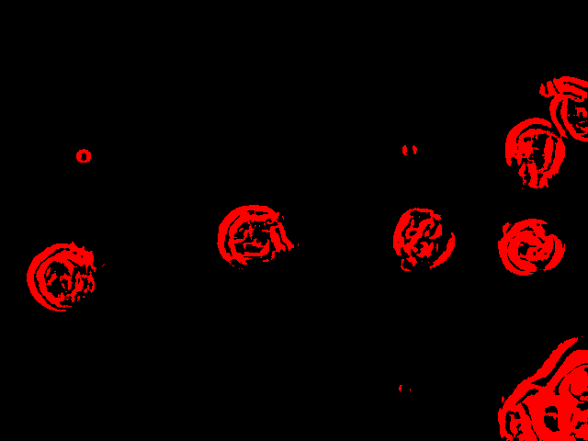

Figure 5. On the left side is the blurred image, on the right side is the image with edges detected

## 3. ROIs mask generation

The following step involves using the detected edges and creating a mask for regions of interest. In this step the redundant edges are eliminated.

|  |  |  |  |  |  |  |  |  |  |  |  |  |  |  |  |
| --- | --- | --- | --- | --- | --- | --- | --- | --- | --- | --- | --- | --- | --- | --- | --- |
| 0 | 1 | 2 | 3 | 4 | 5 | 6 | 7 | 8 | 9 |  |  | scanner area | | | |
| 10 | 11 | 12 | 13 | 14 | 15 | 16 | 17 | 18 | 19 |  |  |
| 20 | 21 | 22 | 23 | 24 | 25 | 26 | 27 | 28 | 29 |  |  |  |  |  |  |
| 30 | 31 | 32 | 33 | 34 | 35 | 36 | 37 | 38 | 39 |  |  |  |  |  |  |
| 40 | 41 | 42 | 43 | 44 | 45 | 46 | 47 | 48 | 49 |  |  |  |  |  |  |
| 50 | 51 | 52 | 53 | 54 | 55 | 56 | 57 | 58 | 59 |  |  |  |  |  |  |
| 60 | 61 | 62 | 63 | 64 | 65 | 66 | 67 | 68 | 69 |  |  |  |  |  |  |
| 70 | 71 | 72 | 73 | 74 | 75 | 76 | 77 | 78 | 79 |  |  |  |  |  |  |
| 80 | 81 | 82 | 83 | 84 | 85 | 86 | 87 | 88 | 89 |  |  |  |  |  |  |
| 90 | 91 | 92 | 93 | 94 | 95 | 96 | 97 | 98 | 99 |  |  |  |  |  |  |

Figure 6. 10x10 image with edges detected surrounded by scanner. The top right area will be marked, the bottom left will be ignored

A custom area is moved across the image and its edge density is calculated. All the pixels in the scanning area is marked if it contains strong edges.

Algorithm

while origin of scanning area is not outside image boundaries

calculate edge density for area

set density to 0

for each pixel in the scanning area

add pixel value to density

return area density related to picture

if density shows a strong edge

mark it

endif

scan to the right

if origin is outside the width of the row

move to next row

endif

After creating the ROIs mask, the result is visible in Figure 7.

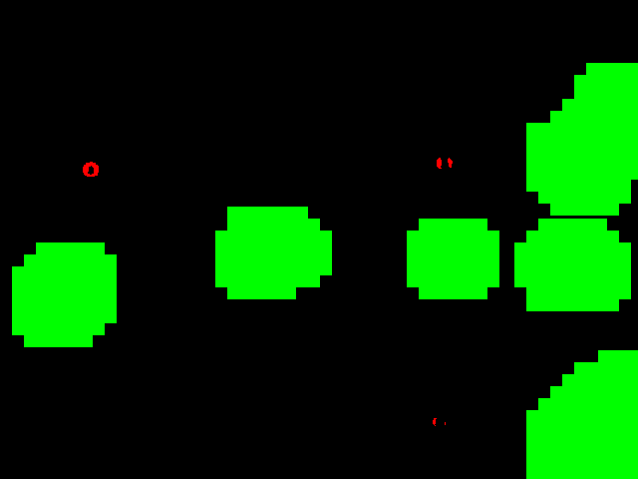

Figure 7. On the left side is the image with edges detected, on the right side is the image with regions of interest

## 4. Highlight the ROIs in the original image

In the last step, all the pixels from the original image are darkened if they are not on the same position as the pixels from the ROI mask. All the pixels of the original image are traversed keeping track of the current index, and from the ROIs map the correspondent value is checked if is a strong edge or not. If the current pixel is not part of a ROI in the ROIs map, then the current value is decreased to 40%, making the pixel darker.

Algorithm

for each pixel in input image:

if the current pixel is green in the ROIs map

output pixel is the current pixel

else

output pixel value is multiplied by 0.4

endif

After applying the ROIs mask to the original image, the result is visible in Figure 8.

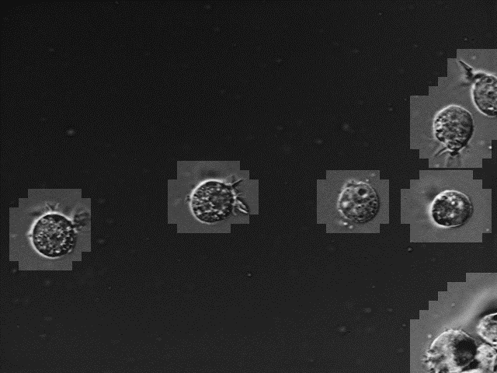

Figure 8. On the top left side is the ROIs mask, on the right side is the image with regions of interest detected. On the bottom left side is the original input image, on the right side is the output image

# Parallelisation and performance

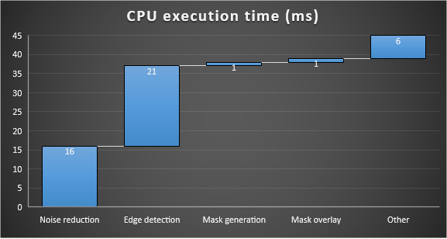Currently the time needed to process one image is 45 milliseconds on an i7-1790 CPU @ 3.6 GHz.

Figure 9. Image Processing time breakdown in milliseconds

As show in figure 9 the most intensive tasks seem to be the noise reduction and edge detection.

The application processes the images in sequence needing a total of 450 milliseconds on average. To improve this, the program will be adapted to run some of the tasks in parallel so the performance and efficiency can both increase.

Contents

Overview 1

Background work 1

Methodology 2

Algorithms and code 2

The PC version 3

1. Noise reduction 3

2. Edge detection 4

3. ROIs mask generation 5

4. Highlight the ROIs in the original image 6

1. Phung, S. L., & Bouzerdoum, A. (2007, April). Detecting people in images: An edge density approach. In *2007 IEEE International Conference on Acoustics, Speech and Signal Processing-ICASSP'07* (Vol. 1, pp. I-1229). IEEE.
2. Juneja, M., & Sandhu, P. S. (2009). Performance evaluation of edge detection techniques for images in spatial domain. *international journal of computer theory and Engineering*, *1*(5), 614.
3. Szeliski, R., 2010. *Computer vision: algorithms and applications*. Springer Science & Business Media., pp.10-16.
4. Canny, J., 1986. A computational approach to edge detection. *IEEE Transactions on pattern analysis and machine intelligence*, (6), pp.679-698.
5. Nalwa, V.S. and Binford, T.O., 1986. On detecting edges. *IEEE transactions on pattern analysis and machine intelligence*, (6), pp. 699-714.
6. Xue, W., Wenxia, X. and Guodong, L., 2015, January. Image Edge Detection Algorithm Research Based on the CNN's Neighborhood Radius Equals 2. In *Proceedings of the 2015 Sixth International Conference on Digital Manufacturing and Automation* (pp. 150-153). IEEE Computer Society.
7. XIA, Z. Q., FENG, X. Y., & PENG, J. Y. (2009). Detecting the Regions of Interest with Edge and Depth Information [J]. *Computer Simulation*, *7*, 062.
8. Itti, L., Koch, C. and Niebur, E., 1998. A model of saliency-based visual attention for rapid scene analysis. *IEEE Transactions on pattern analysis and machine intelligence*, *20*(11), pp.1254-1259.
9. Goz (2016). *How do I gaussian blur an image without using any in-built gaussian functions?*. [online] Stackoverflow.com. Available at: http://stackoverflow.com/questions/1696113/how-do-i-gaussian-blur-an-image-without-using-any-in-built-gaussian-functions [Accessed 11 Nov. 2016].
10. Sobel, I., 2014. History and definition of the sobel operator. *Retrieved from the World Wide Web*.